Altruism vs. Social Norm Results (Main effect ,Moderating effect, Mediating effect)

**Study 1**

***Design*:** 4 gift-giving motivations (altruism vs. pure altruism vs. social norm vs. egoism).

***Manipulations*:**

*Altruism*: Remember that, as compensation for your participation in this experiment, you will get €5. However, you realize that it's your co-worker's birthday tomorrow. Although you are not that close to him, you still wish he can have a nice birthday. To make your co-worker happy, you decide to buy your co-worker a birthday present. All of the gifts, including yours, were given on your co-worker's birthday.

*Pure altruism*: Remember that, as compensation for your participation in this experiment, you will get a 5 euro gift-card. However, you realize that it's your co-worker's birthday tomorrow. Although you are not that close to him, you still wish he can have a nice birthday. To make him happy, you decide to buy your co-worker a birthday present.  All of the gifts, including yours, were given anonymously on your co-worker's birthday.

*Social norm*: Remember that, as compensation for your participation in this experiment, you will get €5. However, you realize that it's your co-worker's birthday tomorrow. Although you are not that close to him, you decide to buy your co-worker a birthday present because it is expected that everyone in the office will give your co-worker a present. All of the gifts, including yours, were given on your co-worker's birthday.

*Egoism*: Remember that, as compensation for your participation in this experiment, you will get €5. However, you realize that it's your co-worker's birthday tomorrow. Although you are not that close to him, you decide to buy your co-worker a birthday present because you want to reinforce your identity as a “team player” that you wish your co-worker to infer you have. All of the gifts, including yours, were given on your co-worker's birthday.

***Altruism vs. Pure Altruism vs. Social Norm.***

We eliminated four outliers for Altruism_ave (NO. 12, 78, 96, 93), one outlier (NO. 8) for SN_ave, and three outliers (NO. 67, 72, 74) for brand_ave (Criterion: observations outside the inner fences (Boxplot)). Furthermore, we eliminated those participants whose durations of doing experiment were beyond +/- 3 SD. In total, we got 74 valid participants.

*Manipulation check.* The results of manipulation check showed that there was a significant difference among conditions in Altruism_ave (*F*(2, 71)= 3.88, *p*= .025). Participants in the pure altruism condition (*M*= 4.99) perceived themselves as being more altruistic than participants in the social norm condition (*M*= 4.34; *p*< .01). Participants in the altruism condition (*M*= 4.72) also perceived themselves as being more altruistic than participants in the social norm condition (*M*= 4.34; NS). The difference among conditions in SN_ave was significant as well (*F*(2, 71)= 3.07, *p*= .053). Participants in the social norm condition (*M*= 4.76) perceived themselves as more obeying social norms than participants in the altruism condition (*M*= 3.75; *p*= .025). Participants in the social norm condition (*M*= 4.76) perceived themselves as more obeying social norms than participants in the pure altruism condition (*M*= 4.09; NS).

*Indulgence*. Brand_ave (16 items, alpha= .94) was the DV. Results indicated that there was a significant difference among conditions in willingness to buy luxury brands (*F*(2, 71)= 3.03, *p*= .055). Participants in the altruism condition (*M*= 3.71) indulged more than participants in the social norm condition (*M*= 2.87; *p*= .044). Participants in the pure altruism condition (*M*= 3.60) also indulged more than participants in the social norm condition (*M*= 2.87; *p*= .046). There was no difference between the altruism (*M*= 3.71) and pure altruism condition (*M*= 3.60, NS.).

*Mediation.* We tested whether happiness, pride, happiness+pride and self-concept were mediating this effect. Happiness, pride and happiness+pride were significant mediators. Self-concept (-.0199 to .5377) was not a significant mediator.

1. Happiness (happy, cheerful, trilled, excited). Using a bootstrapping process (Preacher and Hayes 2004), we identified the indirect path from gift-giving motivation to gift-giver’s indulgence through happiness. The results showed that the indirect effect was significant with a 95% confidence interval that excludes zero (.0202 to .8270).
2. Pride (proud, confident, self-righteous, powerful). Using a bootstrapping process (Preacher and Hayes 2004), we identified the indirect path from gift-giving motivation to gift-giver’s indulgence through pride. The results showed that the indirect effect was significant with a 95% confidence interval that excludes zero (.0727 to .9048).
3. Happiness+Pride (happy, cheerful, trilled, excited, proud, confident, self-righteous, powerful). Using a bootstrapping process (Preacher and Hayes 2004), we identified the indirect path from gift-giving motivation to gift-giver’s indulgence through happiness+pride. The results showed that the indirect effect was significant with a 95% confidence interval that excludes zero (-.8278 to -.0736).

Figure 1

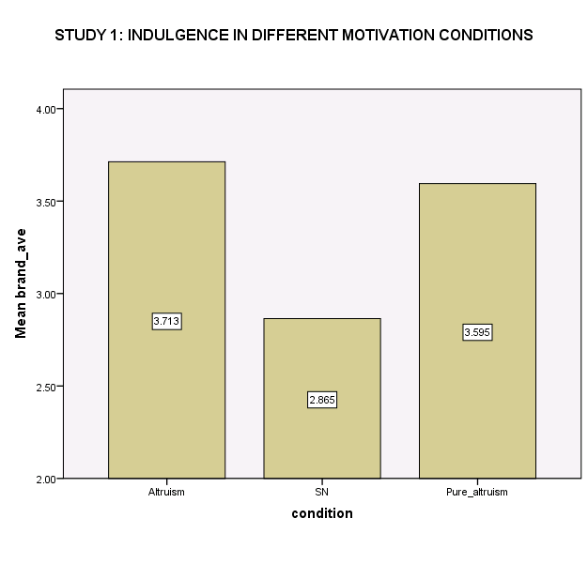

***Altruism vs. Social Norm.***

We eliminated two outliers (NO. 96, 93) for Altruism_ave and three outliers (NO. 67, 72, 74) for brand_ave (Criterion: observations outside the inner fences (Boxplot). In total, we had 50 participants.

*Manipulation check.* Manipulation of altruism was not significant. Participants in the altruism condition (M= 4.66) perceived themselves as slightly more altruistic than participants in the social norm condition (M= 4.34). Manipulation of social norm was significant. Participants in the social norm condition (*M*= 4.76) perceived themselves as obeying social norms more than participants in the altruism condition (*M*= 3.75; *F*(1, 48)= 4.36, *p*= .042).

*Indulgence.* Brand_ave (16 items) was the DV. The results showed that participants in the altruism condition (*M*= 3.74) indulged more than participants in the social norm condition (*M*= 2.87; *F*(1, 48)= 4.96, *p*= .031).

*Mediation.* We tested whether happiness (-.4089 to .0250), pride (-.4002 to 0), and self-concept (-.3289 to .0044) were mediating this effect. None of these mediation tests were significant.

***Pure Altruism vs. Social Norm.***

We eliminated two outliers (NO. 12, 78) for Altruism_ave, one outlier (NO. 8) for SN_ave (Criterion: observations outside the inner fences (Boxplot).). We also eliminated four participants whose durations of doing experiment were beyond +/- 3 SD. In total, we had 55 participants.

*Manipulation check.* Participants in the pure altruism condition (*M*= 4.99) perceived themselves as more altruistic than participants in the social norm condition (*M*= 4.41; *F*(1, 53)= 5.15, *p*= .027). The manipulation of social norm was not significant although the means were in the predicted direction: Participants in the social norm condition (*M*= 4.77) perceived themselves as more obeying social norms than participants in the pure altruism condition (*M*= 4.09).

*Indulgence.* Brand_ave (16 items, alpha= .95) was the DV. The results showed that participants in the pure altruism condition (*M*= 3.60) indulged more than participants in the social norm condition (*M*= 2.80; *F*(1, 53)= 4.04, *p*= .05).

*Mediation*.

DV was brand_ave (16 items, alpha= .95). We tested whether happiness, pride, and self-concept were mediating this effect. Pride was a significant mediator. Happiness (-.0956 to .9445) and self-concept (-.0233 to .6966) were not significant mediators.

1. Pride (proud, confident, self-righteous, powerful). Using a bootstrapping process (Preacher and Hayes 2004), we identified the indirect path from gift-giving motivation to gift-giver’s indulgence through pride. The results showed that the indirect effect was significant with a 95% confidence interval that excludes zero (.0189 to .7547).

**Study 2**

***Design***: 3 gift-giving motivations (altruism vs. social norm vs. egoism) x measured perception of indulgence as moral or immoral.

***Manipulations***: as in study 1.

***Altruism vs. Social Norm.(DV: Willingness to buy luxury brands)***

We eliminated three outliers (NO. 7, 140, 145) for SN_ave, we eliminated 8 outliers (NO. 106, 126, 104, 70, 18, 46, 131, 43) for the perception of morality (Criterion: observations outside the inner fences (Boxplot).). We had 62 valid participants.

*Manipulation check.* Participants in the altruism condition (*M*= 5.44) perceived themselves as more altruistic than participants in the social norm condition (*M*= 4.81; *F*(1, 60)= 6.16, *p*= .016). Participants in the social norm condition (*M*= 5.48) perceived themselves as obeying social norms more than participants in the altruism condition (*M*= 3.64; *F*(1, 60)= 23.58, *p*< .01).

*Indulgence*. DV was Brand_ave (21 items, alpha= .95). Moderator was the perception of indulgence as moral or immoral. Participants rated their perceptions of indulgence on a 7-point Likert scale (1= I think they are morally inappropriate, 7= I think they are morally appropriate).We mean-centered the perception of morality. The interaction between perception of morality and gift-giving motivation was not significant. We computed the simple slopes of the fitting lines of altruism condition and social norm condition. The more moral participants perceived indulgences to be, the more participants in the altruism condition tended to indulge (*B*= .48; *t*(29)= 1.86, *p*= .073). There was no significant change in indulgence for participants in the social norm condition when perception of morality increased (*B*= .15; *t*(30)= .94, NS). Spotlight analysis showed that when participants perceived indulgence as moral (+1 SD), participants in the altruism condition (*M*= 4.21) indulged more than participants in the social norm condition (*M*= 4.15). But when indulgence was perceived as immoral (-1 SD), participants in the altruism condition (*M*= 3.05) indulged less than participants in the social norm condition (*M*= 3.79; see fig.2).   
I think the reason why there was no significant interaction between perception of morality and gift-giving motivation could be that the sample (N = 62) was too small.

*Mediation*. We tested whether happiness, pride, happiness+pride and self-concept were mediating this effect. Happiness (-.1701 to .5579) was not a significant mediator. Pride (-.1377 to .3054) was not a significant mediator. Self-concept (-.0505 to .4643) was not a significant mediator. Happiness+Pride (-.1568 to .4638) was not a significant mediator.

Figure 2

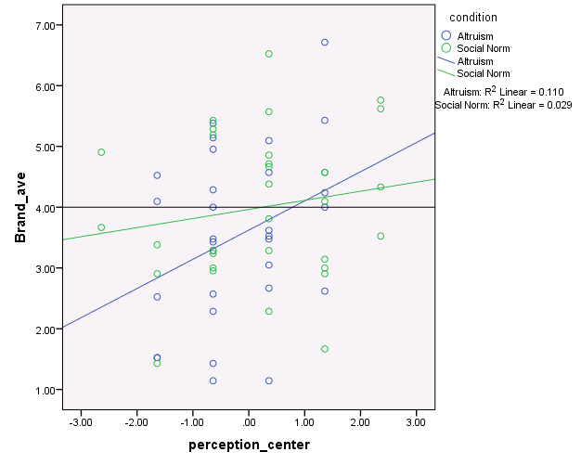

***Altruism vs. Social Norm.(DV: Willingness to buy indulgent products)***

We eliminated three outliers (NO. 140, 145, 7) for SN_ave, one outlier (NO. 35) for Indulgence_ave (Criterion: observations outside the inner fences (Boxplot)). In total, we had 69 valid participants.

*Manipulation Check*. The manipulation of altruism was significant (*F*(1, 67)= 7.85, *p*< .01). Participants in the altruism condition (*M*= 5.52) perceived themselves as being more altruistic than participants in the social norm condition (*M*= 4.84). The manipulation of social norm was significant (*F*(1, 67)= 22.03, *p*< .01). Participants in the social norm condition (*M*= 5.48) perceived themselves as more obeying social norms than participants in the altruism condition (*M*= 3.76).

*Indulgence*. DV was Indulgence_ave (8 items, alpha= .57). Moderator was the perception of indulgence as moral or immoral. Participants rated their perceptions of indulgence on a 7-point Likert scale (1= I think they are morally inappropriate, 7= I think they are morally appropriate).We mean-centered the perception of morality. The interaction between gift-giving motivation and the perception of indulgence was significant (*F*(1, 65)= 9.29, *p*< .01). Spotlight analysis showed that when participants perceived indulgence as moral (+1 SD), participants in the altruism condition (*M*= 3.65) indulged more than participants in the social norm condition (*M*= 2.80). But when indulgence was perceived as immoral (-1 SD), participants in the altruism condition (*M*= 2.97) indulged less than participants in the social norm condition (*M*= 3.60; see fig.3). Floodlight analysis revealed that when the perception of indulgence was below -1.58 (*B*= -.74, *SE*= .37, *p*=.05) or above 1.06 (*B*= .56, *SE*= .28, *p*= .05), there was a significant difference in indulgence between altruism condition and social norm condition. We computed the simple slopes of the fitting lines of altruism condition and social norm condition. The more moral participants perceived indulgences to be, the more participants in the altruism condition tended to indulge (*B*= .23; *t*(35)= 1.85, *p*= .072). But the less moral participants perceived indulgences to be, the more participants in the social norm condition tended to indulge (*B*= -.27; *t*(30)= -2.59, *p*= .015).

*Mediation*. We tested whether happiness, pride, happiness+pride and self-concept were mediating this effect. Pride (-.0156 to .2729) was not a significant mediator. Happiness, happiness+pride and self-concept were significant mediators.

1. Happiness+Pride (happy, cheerful, thrilled, excited, proud, confident, self-righteous, powerful). Using a bootstrapping process (Preacher and Hayes 2004), we identified the indirect path from gift-giving motivation to gift-giver’s indulgence through happiness+pride. The results showed that the indirect effect was significant with a 95% confidence interval that excludes zero (.0442 to .4566).
2. Happiness (happy, cheerful, thrilled, excited). Using a bootstrapping process (Preacher and Hayes 2004), we identified the indirect path from gift-giving motivation to gift-giver’s indulgence through happiness. The results showed that the indirect effect was significant with a 95% confidence interval that excludes zero (.1045 to .6130).
3. Self-concept (compassionate, sympathetic, warm, helpful). Using a bootstrapping process (Preacher and Hayes 2004), we identified the indirect path from gift-giving motivation to gift-giver’s indulgence through self-concept. The results showed that the indirect effect was significant with a 95% confidence interval that excludes zero (.0357 to .4139).

Figure 3

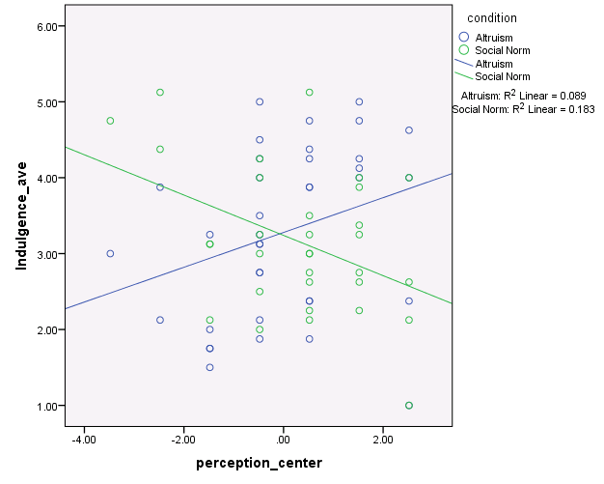

**Study 3**

***Design***: 3 gift-giving motivations (altruism vs. social norm vs. egoism) x measured perception of indulgence as moral or immoral.

***Manipulations***: as in study 1.

***Altruism vs. Social Norm.***

We eliminated 2 outliers (NO. 123, 165) for Altruism_ave (Criterion: observations outside the inner fences (Boxplot).). In total, we had 99 valid participants.

*Manipulation check*. Participants in the altruism condition (*M*= 5.19) perceived themselves as being more altruistic than participants in the social norm condition (*M*= 4.76; *F*(1, 97)= 5.01, *p*= .027). Participants in the social norm condition (*M*= 4.76) perceived themselves as more obeying social norms than participants in the altruism condition (*M*= 3.75; *F*(1, 97)= 9.88, *p*< .01).

*Indulgence*. DV was Brand_ave (21 items, alpha= .91). Moderator was the perception of indulgence as moral or immoral. Participants rated their perceptions of indulgence on a 7-point Likert scale (1= I think they are morally inappropriate, 7= I think they are morally appropriate). We mean-centered the perception of morality.

Results showed that there was a significant interaction between the perception of morality and gift-giving motivation (*B*= .29, *t*(95)= 1.97, *p*= .051). To further understand this interaction, we computed the slopes of the two fitting lines of the altruism condition and the social norm condition. The more indulgence was perceived as moral, the more participants in the altruism condition tended to indulge (*B*= .28; *t*(48)= 2.63, *p*= .011; see fig.4). But for participants in the social norm condition, their willingness to buy luxury brands was not influenced by the perception of morality (*B*= -.016; *t*(47)= -.16, NS).

Spotlight analysis did not show significant differences at +/- 1SD, but the means are in the predicted direction: When indulgence was perceived as moral (+1 SD), participants in the altruism condition (*M*= 4.00) indulged more than participants in the social norm condition (*M*= 3.59). But when indulgence was perceived as immoral (-1 SD), participants in the altruism condition (*M*= 3.08) indulged less than participants in the social norm condition (*M*= 3.65).

Figure 4

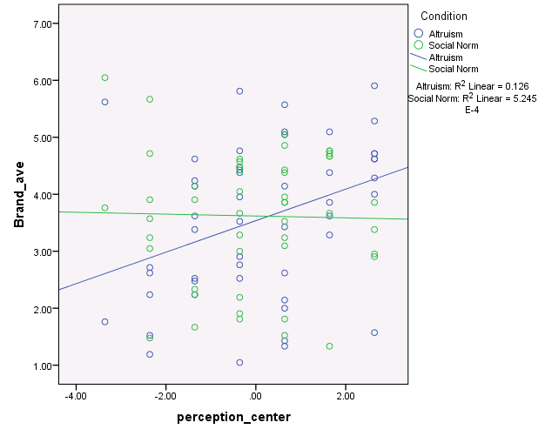

*Mediation.* We tested whether happiness, pride, happiness+pride and self-concept were mediating this effect. Happiness, pride and happiness+pride were significant mediators. Self-concept (-.1211 to .0466) was not a significant mediator.

1. Happiness (happy, cheerful, thrilled, excited). Using a bootstrapping process (Preacher and Hayes 2004), we identified the indirect path from gift-giving motivation to gift-giver’s indulgence through happiness. The results showed that the indirect effect was significant with a 95% confidence interval that excludes zero (.0802 to .5624).
2. Pride (proud, confident, self-righteous, powerful). Using a bootstrapping process (Preacher and Hayes 2004), we identified the indirect path from gift-giving motivation to gift-giver’s indulgence through pride. The results showed that the indirect effect was significant with a 95% confidence interval that excludes zero (.0453 to .4223).
3. Happiness+Pride (happy, cheerful, thrilled, excited, proud, confident, self-righteous, powerful). Using a bootstrapping process (Preacher and Hayes 2004), we identified the indirect path from gift-giving motivation to gift-giver’s indulgence through happiness+pride. The results showed that the indirect effect was significant with a 95% confidence interval that excludes zero (.0986 to .5898).